HELLENIC REPUBLIC | FACULTY OF HEALTH SCIENCES
 | DEPARTMENT OF MEDICINE  MSc in HEALTH STATISTICS & DATA ANALYTICS | 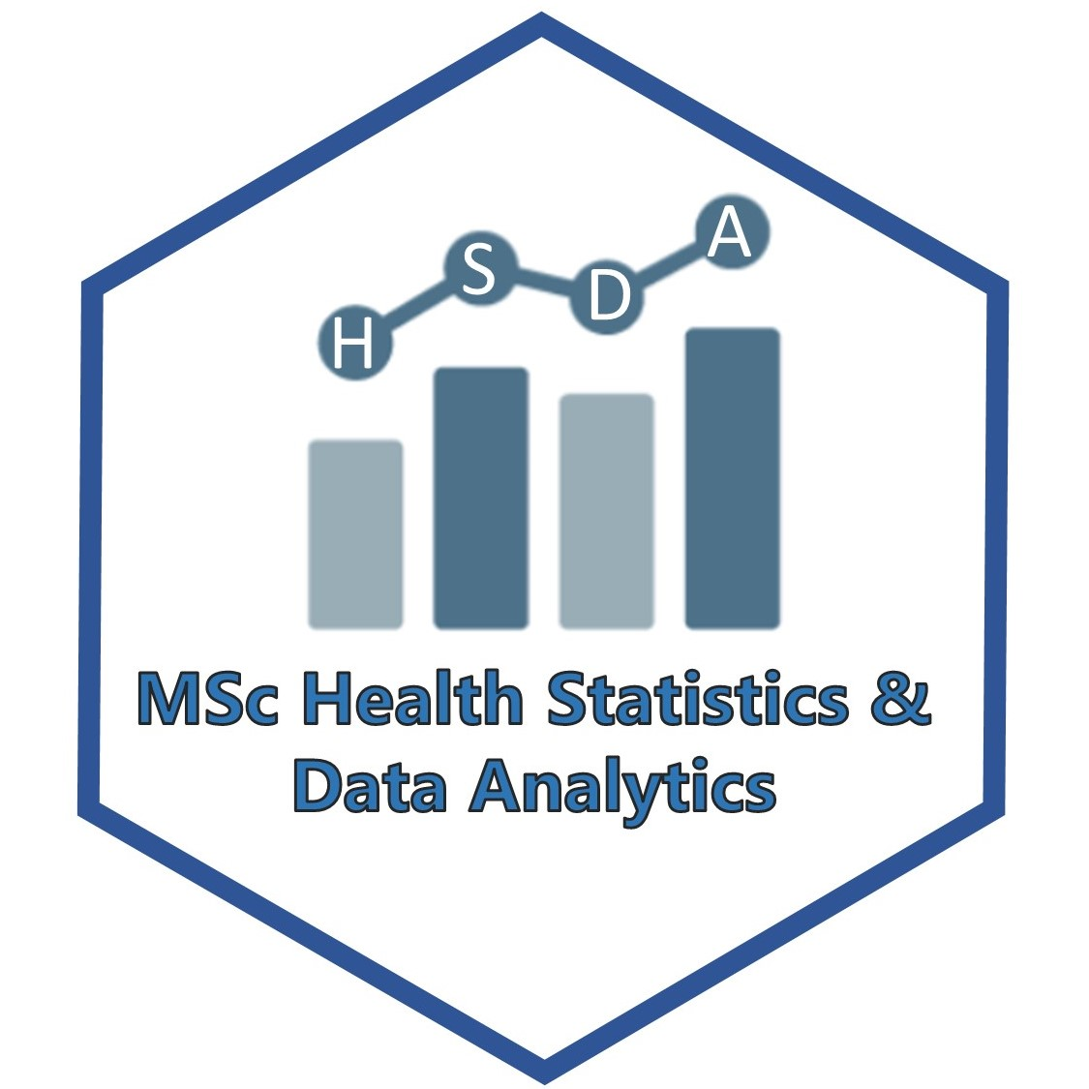
ARISTOTLE  UNIVERSITY  THESSALONIKI | T: +30 2310 99 9148  E: info-hsda@auth.gr, W: hsda.med.auth.gr

Thessaloniki, / / 2021

Application form

Please, accept my application form for the MSc Health Statistics & Data Analytics.

Name

Surname

Father name
and surname
Mother name
and surname
Nationality

Address

Zip code

City

Phone
E-mail

Tax Identification number (ΑΦΜ)
Financing body
(ΔΟΥ)
I hold a bachelor / MSc / PhD / other degree(s) in/from | Bachelor in Medicine, Aristotle University of Thessaloniki

I agree to abide by the MSc Program regulations | YES □ NO □

Attachments

1. | Bachelor / MSc / PhD / other degree(s).
2. | Recognition Degree from ΔΟΑΤΑΠ (if needed)
3. | Recently updated Curriculum Vitae, with details about education, training, work experience, academic publications and academic achievements (i.e. Europass template).
4. | Proof of competency in English language.
5. | Photocopy of personal ID or passport with personal details.
6. | Two (2) recent reference letters written in English and referring to the MSc candidacy.

