HELLENIC REPUBLIC | FACULTY OF HEALTH SCIENCES
 | DEPARTMENT OF MEDICINE  MSc HEALTH STATISTICS AND DATA ANALYTICS | 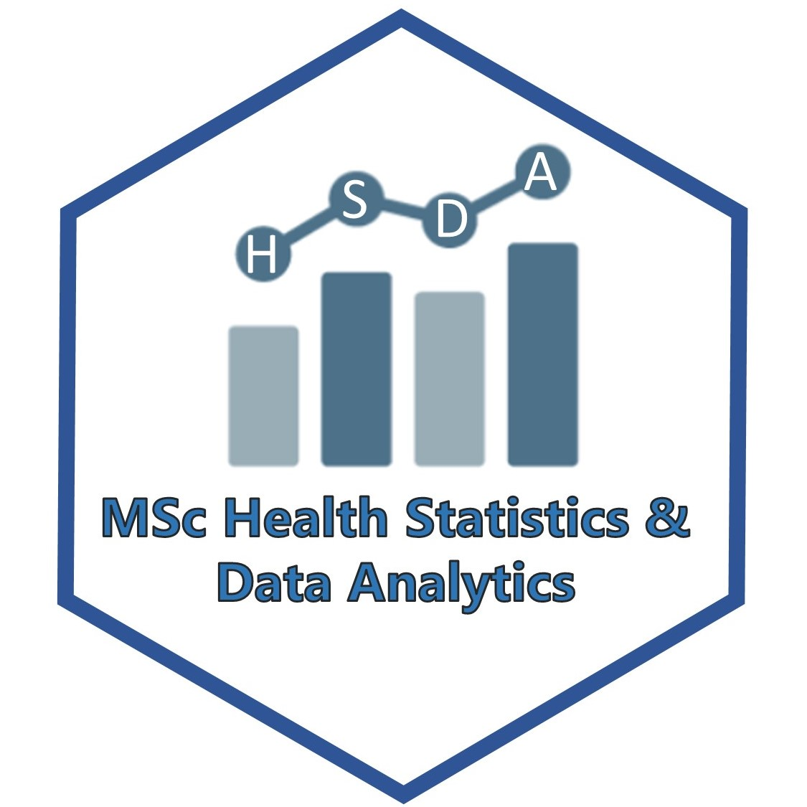
ARISTOTLE  UNIVERSITY  THESSALONIKI | T: +30 2310 99 9148  E: info-hsda@auth.gr  W: hsda.med.auth.gr | Thessaloniki, 29 July 2021

Statement of purpose

Applicant name, surname
Relevant academic, research or practical experience
Reasons for applying to this particular programme
Areas of study in the subject that interest me

